|  |
| --- |
| **NSW Traffic Data Analysis User Manual** |
| Anuj , Puneet, Raghav7810ICT Software TechnologiesOctober 8, 2023 |

# Introduction

Welcome to the NSW Traffic Data Analysis Software. This software, built using Python and wxFormBuilder, is designed to assist you in analyzing traffic data related to Penalty cases. In this user manual, we will walk you through the various features and functionalities of the software, helping you make the most out of it.

## **Getting Started**

1. **Installation**: Make sure you have installed the required dependencies. The application is designed to run using Conda environment.
2. **Application Files**: The core files of the application are located in the "App" folder.
3. **Running the Application**: To start the application, run the "main.py" file located in the "PyApp" folder.
4. **CSV File**: Ensure you have a CSV file with the necessary data. The location of the CSV file should be specified in the "csvFileLocation.py" file within the "App" folder.

Now, let's explore the main pages and features of the application:

## **Main Pages**

1. **Find Penalty Case**: This page allows you to search for specific penalty cases within the provided CSV data. You can enter relevant search criteria to retrieve the information you need.
2. **Search Offence**: Use this page to search for specific offenses recorded in the CSV data. You can filter and find specific offenses based on your criteria.
3. **Generate Graph**: This feature enables you to generate visual graphs and charts based on the data from the CSV file. It helps in visualizing trends and patterns.
4. **Get Report**: Access detailed reports and summaries of the data. You can create and export reports based on the data analysis performed within the application.
5. **Mobile Cases**: This page is dedicated to managing mobile cases. You can view, edit, and update mobile-related information in this section.

## **Navigating the Application**

The software features a user-friendly top navigation menu that provides quick access to its five main pages. The application interface is designed to be user-friendly. You will find menu options, buttons, and input fields to interact with the software's features. Detailed instructions for each page and feature will be provided in the respective sections of this user manual.

# Find Penalty Cases

The "Find Penalty Cases" page serves as the homepage of the application. When you open the application, this page is displayed, providing a comprehensive view of your data in a table format. This page allows you to search and filter the data to find specific penalty cases efficiently.

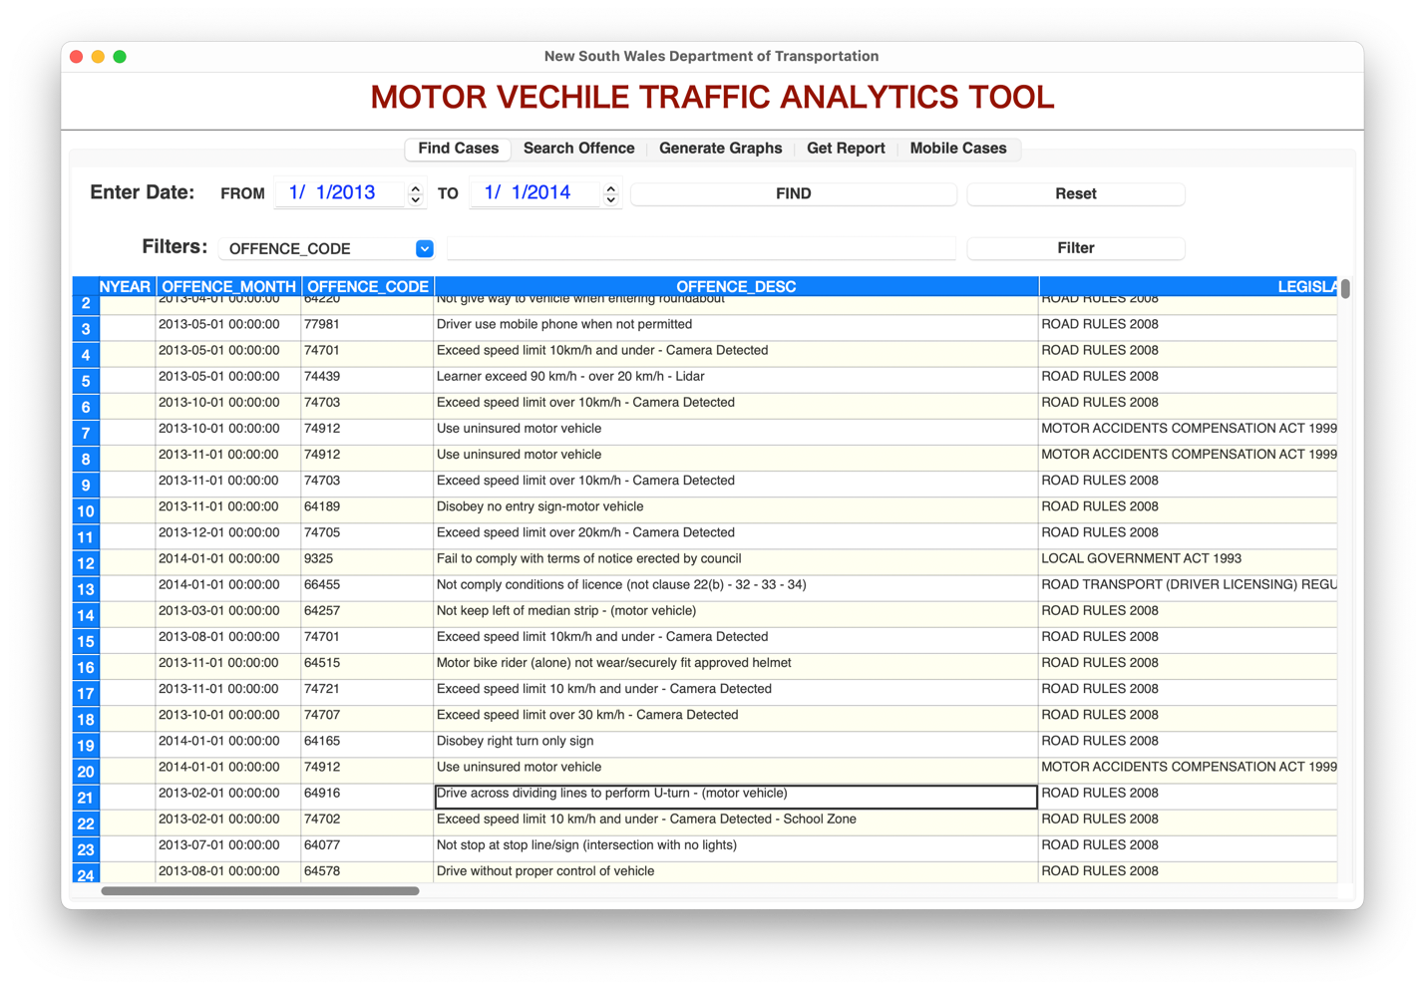

**Features:**

**1. Table Display**

* Upon opening the application, you will see all your data displayed in a table format. This table provides an overview of your data, including various columns containing relevant information.

**2. Date Selector**

* To narrow down your search, you can use the date selector. Enter a specific date and click the "Find" button located next to it. The table will update to display only the data entries that match the selected date.

**3. Additional Filters**

* For more refined searches, you have the option to apply additional filters. Here's how it works:

**Filter Type Dropdown**: Choose a filter type from the dropdown menu. This dropdown contains filter options based on the columns in your data.

**Filter Input**: Enter your filter criteria in the input field next to the filter type dropdown.

**Filter Button**: Click the "Filter" button next to the filter input to apply the selected filter. The table will update to display only the data entries that match your filter criteria.

**4. Reset Button**

* If you want to clear all filters and return to displaying all data, you can use the "Reset" button located next to the "Find" button. Clicking this button will remove any applied filters and show the complete dataset again.

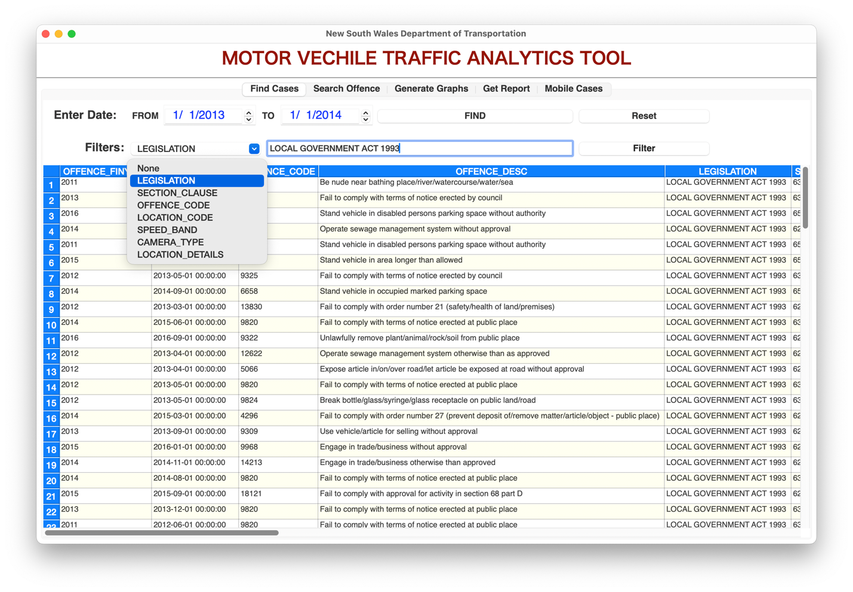

**How to Use:**

1. **Opening the Page**: When you launch the application, you will be directed to the "Find Penalty Cases" page automatically.
2. **Searching by Date**:

* Select a specific date using the date selector.
* Click the "Find" button next to the date selector to display data entries for that date.

1. **Applying Additional Filters**:

* Choose a filter type from the dropdown menu.
* Enter your filter criteria in the input field next to the filter type dropdown.
* Click the "Filter" button next to the filter input to apply the selected filter.

1. **Resetting Filters**:

* To remove all applied filters and show all data again, simply click the "Reset" button next to the "Find" button.

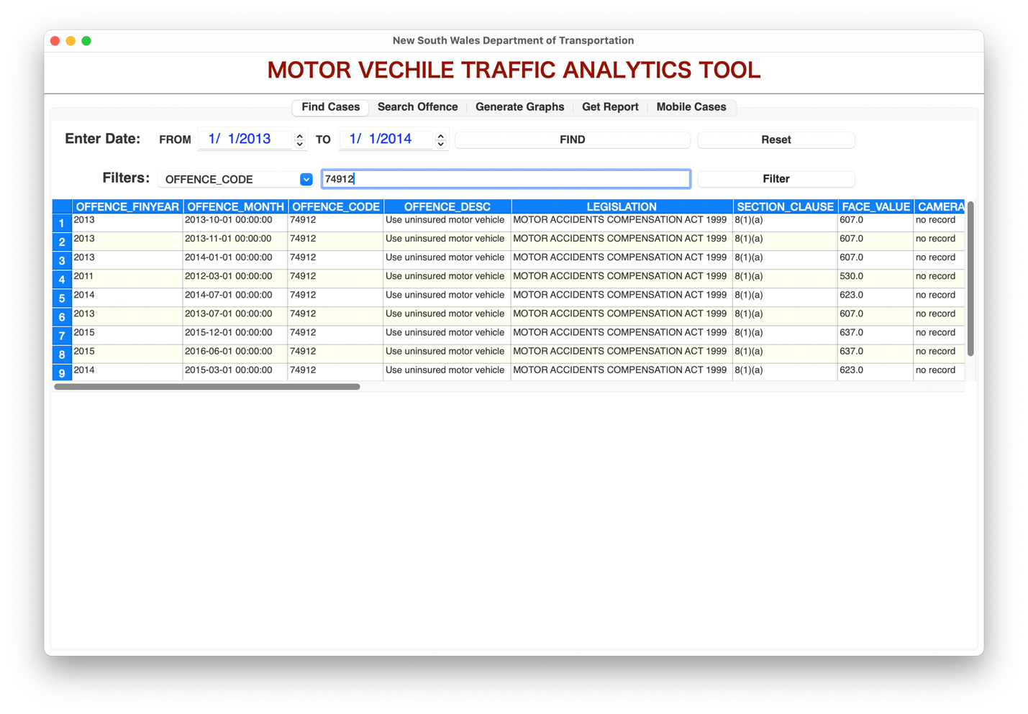Use these features to efficiently search and filter penalty cases based on your criteria, providing you with the specific data you need.

# Search Offence

The "Search Offence" page provides you with a convenient way to search for specific offenses based on a date period and offense descriptions. This feature allows you to find relevant data by entering keywords, related words, or sentences related to the offense description.

**Features:**

**1. Date Selector**

* Begin by selecting a date period using the date selector. You can specify a start date and an end date to narrow down your search to a specific time frame.

**2. Offense Description Search**

* The primary search functionality on this page is the "Offense Description" search field. Here's how it works:

**Search Field**: Type any keyword, related words, or a sentence related to the offense description you're looking for.

**Find Button**: Click the "Find" button below the search field to initiate the search.

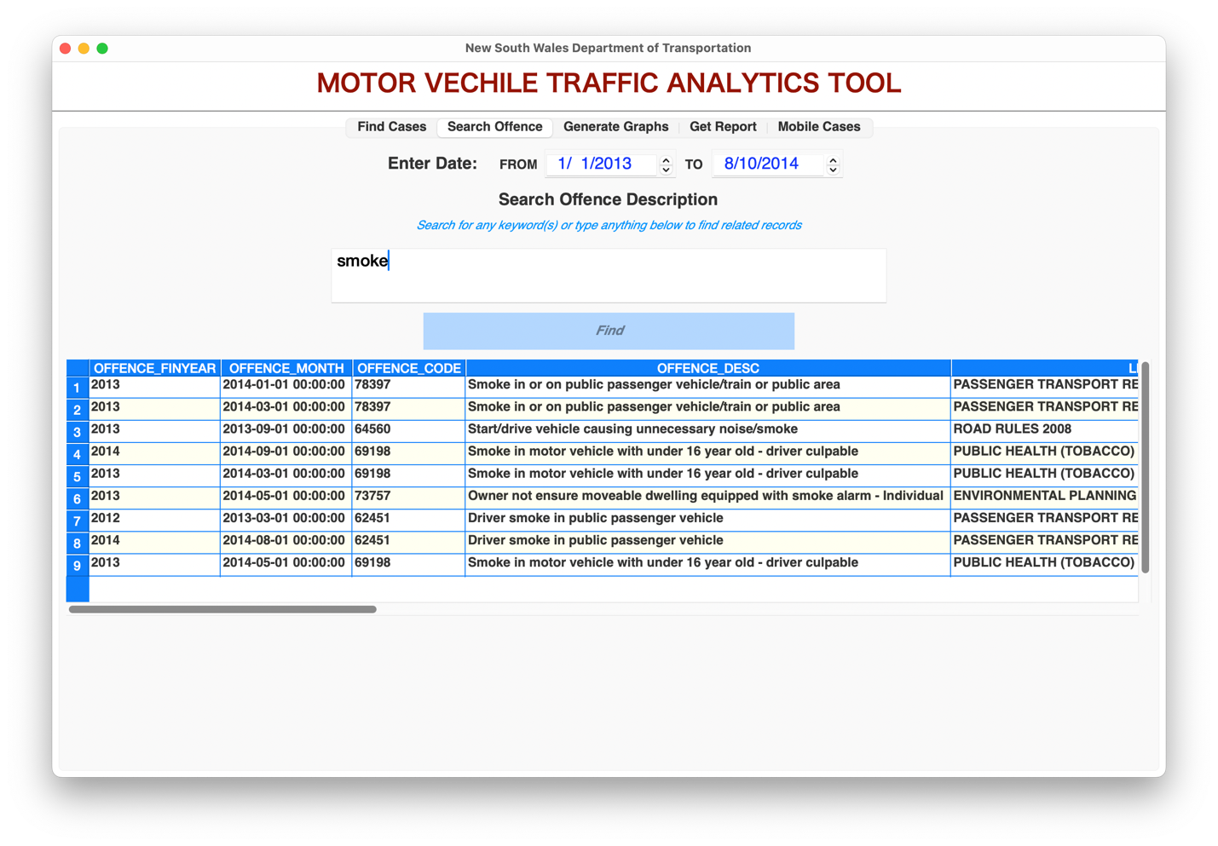

**How to Use:**

1. **Selecting Date Period**:

* Use the date selector to specify a date period. This will help you filter data within the specified time frame.

1. **Searching Offenses**:

* In the "Offense Description" search field, type the keyword, related words, or a sentence related to the offense description you want to find.
* Click the "Find" button below the search field to initiate the search.

1. **Viewing Results**:

After clicking the "Find" button, the search results will be displayed on the screen. The table will show data entries that match your search criteria within the selected date period.

# Generate Graph

The "Generate Graph" page empowers you to create various types of graphs and charts based on your data. You can choose the chart type, specify a date range, and then generate the graph of your choice. Additionally, you have the option to export the generated graph as an image.

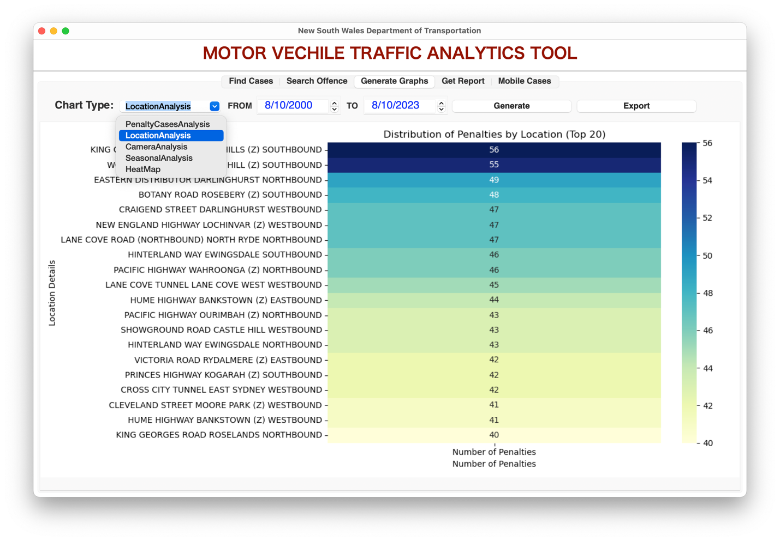

**Features:**

**1. Chart Type Selection**

To get started, select a chart type from the dropdown menu. This dropdown provides a variety of chart options to visualize your data effectively. Choose the chart type that best suits your analysis needs.

**2. Date Selector**

Specify a date range by using the date selector. This allows you to filter your data to include only the entries within the chosen date period.

**3. Generate Button**

After selecting the chart type and specifying the date range, click the "Generate" button. This action will generate and display the selected graph based on the filtered data.

**4. Export Button**

Next to the generated graph, you will find an "Export" button. Use this button to export the graph as an image file. This feature enables you to save and share your graph for further analysis or reporting.

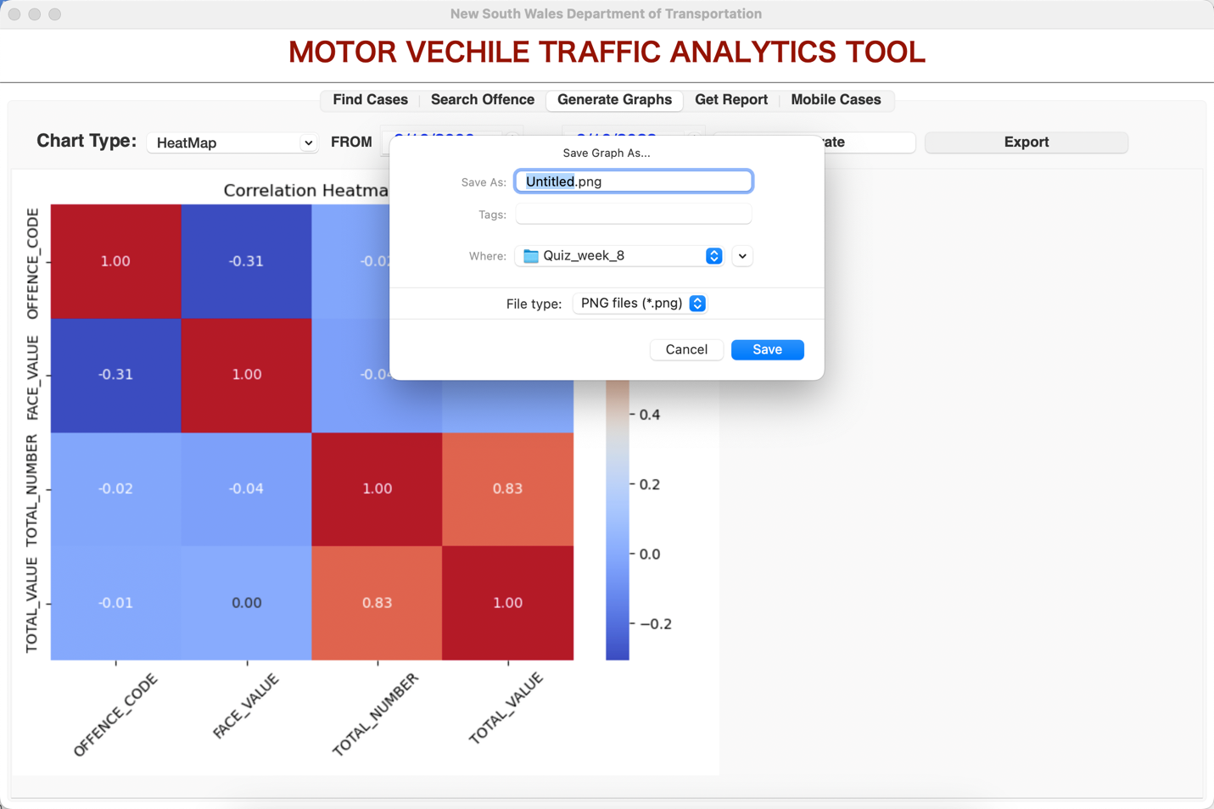

**How to Use:**

1. **Selecting Chart Type**:

Begin by choosing the appropriate chart type from the dropdown menu. This selection determines the style and format of the graph you want to create.

1. **Specifying Date Range**:

Use the date selector to define a date range for your data. This helps in focusing your analysis on a specific period.

1. **Generating the Graph**:

Click the "Generate" button after setting the chart type and date range. The graph will be generated and displayed on the page, visualizing the data based on your selections.

1. **Exporting the Graph**:

If you wish to save the graph as an image, click the "Export" button located next to the generated graph. You can then choose a destination to save the graph as an image file.

Utilize the "Generate Graph" page to create insightful visualizations of your data and export them for further reference or sharing.

# Get Report

The "Get Report" page allows you to generate comprehensive reports based on the selected date period and graph type. You can enter a date range using the date selector, choose the graph type from the dropdown menu, and then generate the report. You also have the flexibility to change the graph type and view multiple reports.

**Features:**

**1. Date Selector**

* Start by specifying a date range using the date selector. This date range will determine the data included in the report.

**2. Graph Type Selection**

* Next to the date selector, you will find a dropdown menu for selecting the graph type. This menu provides various options for the type of graph or chart you want to include in the report.

**3. Generate Button**

* After setting the date range and graph type, click the "Generate" button. This action generates a report that includes the selected graph based on the specified date period.

**4. Changing Graph Type**

* If you want to view multiple types of graphs in the report, simply change the graph type from the dropdown menu and click the "Generate" button again. The report will update to include the new graph while preserving the previous one.

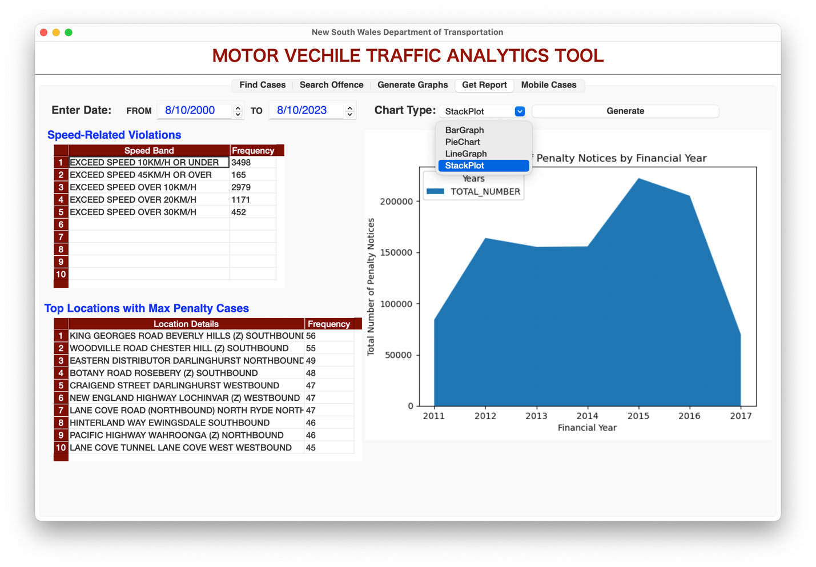

**How to Use:**

1. **Selecting Date Range**:

Use the date selector to define the date period you want to include in the report. This helps in focusing the report on specific data within the chosen time frame.

1. **Choosing Graph Type**:

Select the graph type you wish to include in the report from the dropdown menu. The available options allow you to choose the most appropriate visualization for your data.

1. **Generating the Report**:

Click the "Generate" button after setting the date range and graph type. The report will be generated and displayed, including the selected graph and data based on your selections.

1. **Changing Graph Type (Optional)**:

* To include additional graphs in the report, change the graph type from the dropdown menu.
* Click the "Generate" button again to update the report with the new graph while keeping the previous one.

Utilize the "Get Report" page to create detailed reports with various graph types, providing you with valuable insights into your data.

**Mobile Cases**

The "Mobile Cases" page provides a straightforward way to access and analyze mobile phone cases data. To view the analysis, simply click the "Click Here for Mobile Analysis" button located at the top of the page.

**Features:**

**1. Mobile Phone Cases Analysis**

* The primary feature of this page is the "Click Here for Mobile Analysis" button. By clicking this button, you will instantly access the mobile phone cases analysis.

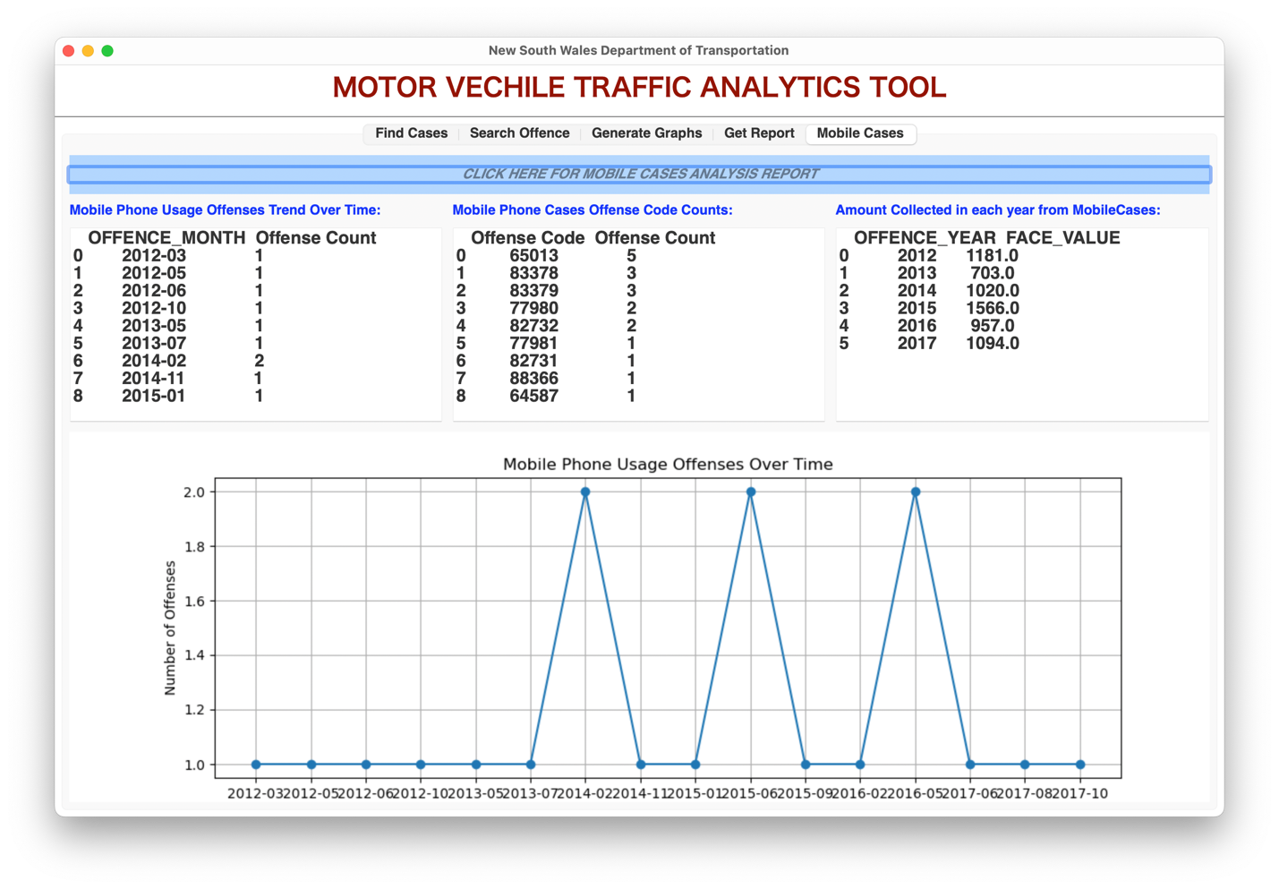

**How to Use:**

1. **Accessing Mobile Phone Cases Analysis**:

* To view the analysis of mobile phone cases, navigate to the "Mobile Cases" page.
* Simply click the prominently displayed "Click Here for Mobile Analysis" button at the top of the page.

The "Mobile Cases" page is designed for quick and convenient access to mobile phone cases analysis, allowing you to gather insights without the need for additional inputs or selections.